| **SKIMMING & SCANNING** |
| --- |

Skimming and scanning are two very different strategies for *speed reading*. They are each used for different purposes, and they are not meant to be used all the time. They are at the fast end of the speed reading range while studying is at the slow end. People who know how to skim and scan are flexible readers. They read according to their purpose and get the information they need quickly without wasting time. They do not read everything which is what increases their reading speed. Their skill lies in knowing what specific information to read and which method to use.

**Scanning Text**

Scanning is for searching particular information or checking to see whether a passage is relevant.

* Look for relevant keywords in the contents and index pages
* Run your finger down the page and pay attention to the search for keywords

**Skim Reading**

Skimming refers to looking only for the general or main ideas and works best for non-fiction (factual) material.

* Read the topic sentence - usually the first sentence - of each paragraph to see what it is about
* Read summaries, headings and subheadings
* Look at tables, diagrams, illustrations etc.

In an **academic context**, skimming and scanning can be used to:

* Quickly identify the main points of a text: Skimming can help you get an overview of the content of a book or article before diving into it in more detail.
* Locate specific information: Scanning can help you find specific details or facts in a text, such as a particular author or a date.
* Conduct research: Skimming and scanning can be useful when conducting research, allowing you to quickly identify relevant sources and locate the information you need.
* Save time: Skimming and scanning can be time-efficient strategies for managing large volumes of information, allowing you to focus on what is most important.

Skimming and scanning are also useful reading strategies in a **professional setting**. Here are some of the ways that these techniques can be applied in the workplace:

* Reviewing reports: Skimming can be used to quickly review reports, presentations, or other documents before delving into them in more detail. This can help to identify key points and save time when reviewing lengthy documents.
* Identifying relevant information: Scanning can be used to quickly locate specific information in a document, such as a client's name or a project deadline.
* Prioritizing emails: Skimming can be used to quickly scan through emails and prioritize them based on urgency or importance.
* Researching competitors: Skimming and scanning can be used to quickly review information about competitors, such as their products, services, or pricing.
* Reviewing contracts: Scanning can be used to quickly review legal contracts and identify key terms or clauses.

**Exercise 1: Skimming and Scanning (Identify)**

Consider the following actions and determine if it is skimming or scanning.

1. Checking the current news in The Daily Star.
2. Searching for a word in the dictionary.
3. Looking for the specific year of establishment of a theory.
4. Reading a notice board very quickly.
5. Reading the guidelines of starting a device.

**Exercise 2: Skimming and Scanning**

Use this information about the Frimsborough County library to answer the questions. Put a tick mark on the correct option and write whether the question is based on scanning or skimming beside each question.

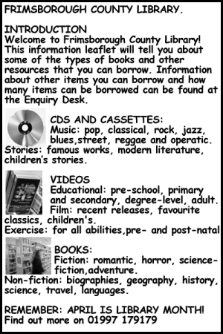

1. The text is aimed at:

A) Librarians

B) Library users

C) Council workers

D) School students

2. Which category of video isn’t listed?

A) Educational

B) Exercise

) Film

D) Travel

3. Which month is ‘library month’?

A) November

B) August

C) September

D) April

4. What is the name of the library?

A) Frimsborough Town Library

B) Frimsborough County Library

C) Frimsborough Village Library

D) Framborough District Library

5. What type of text is this text?

A) Informative

B) Descriptive

C) Persuasive

D) Instructive

Use this information about the Karina furniture suite to answer the questions. Put a tick mark on the correct option and write whether the question is based on scanning or skimming beside each question.



1. The text is aimed at

A) People who are selling furniture

B) People who want to buy furniture

C) Karina

2. Does the catalog company offer a home delivery service?

A) Yes. It costs £100.00.

B) Yes. Delivery is free.

C) There is no delivery service offered.

D) Yes, but the cost of the service is unknown.

3. For what type of use is the Karina range designed/made?

A) Heavy domestic use

B) General domestic use

C) Light domestic use

D) commercial use

4. How many pieces of furniture cost more than £350?

A) 1

B) 2

C) 3

D) 4

5. The futon costs more than the armchair.

A) True

B) False

**Exercise 4: Skimming and Scanning**

Look at this text and then answer the following questions. Put a tick mark on the correct option and write whether the question is based on scanning or skimming beside each question.

**PHOBIAS**

What is a phobia?

A phobia is an intense fear or feeling of anxiety that occurs only in a particular situation that frightens you. This might be something as seemingly logical as a fear of heights, or as illogical as a fear of the color green. At other times you don’t feel anxious. For example, if you have a phobia of spiders (as millions of people do), you only feel anxious when there’s a spider around, otherwise, you feel fine. About one in ten people has a significant phobia, although few people seek treatment. People develop phobias for all sorts of things. Each phobia has its name. Some (of a very long list) include:

∙ Musophobia – fear of mice

∙ Peladophobia – fear of bald people

∙ Amathophobia – fear of dust

∙ Pnigophobia – fear of choking or smothering

∙ Maieusiophobia – fear of childbirth

∙ Homichlophobia – fear of fog

∙ Arachibutyrophobia – fear of peanut butter sticking to the roof of the mouth

Phobias make people avoid situations they know will make them anxious, but this can make the phobia worse. A person’s life can become increasingly dominated by the precautions they take to avoid a situation they fear. You may know there’s no real danger and you may feel embarrassed by your fear, but you’re still unable to control it. It’s better to confront your fears, even if it’s in a very careful way or with the help of a trained therapist.

A phobia is more likely to go away if it begins after a distressing or traumatic event. What’s the treatment?

Cognitive behavioural therapy – a ‘talking treatment’ where you learn all about the thing or situation you are scared of and how to change your behaviour – has a high success rate in phobias. Your GP can refer you.

1. The purpose of the text is to ...

A) give information about phobias

B) give instructions for people with phobias

C) persuade people with phobias to seek help

2. A phobia …

A) happens to everyone when they are frightened

B) happens only in certain situations

C) only happens to anxious people

3. Phobias ...

A) are logical

B) are not logical

C) can be logical or not logical

4. The number of people who have phobias is ...

A) five out of ten people

B) ten people

C) 10 per cent of the population

5. Peladophobia is ...

A) fear of bald people

B) fear of dust

C) fear of fog

6. The writer advises people with phobias to ...

A) consult a psychotherapist

B) avoid situations that make them anxious

C) confront the fear rather than avoid

it

7. Which of these phobias is not mentioned in the text?

A) Arachibutyrophobia

B) Arachnophobia

C) Amathophobia

8. What is the main message of this article?

A) Some people have phobias and live in fear of certain things.

B) If you have a phobia you should see a therapist.

C) What a phobia is and how to treat it.

**Exercise 5: Skimming and Scanning**

**Skim and scan the text to answer the following questions in complete sentences.**

**Critical Skills for the Workplace in the 21st Century**

# **Abdul Warith Khan**

Skill means the ability to do something well or perform successfully, usually gained through experience and training. We can acquire many skills during our lives, especially young ones. There are many critical skills college or university students try to acquire as preparation for a career. Understanding how to develop 21st-century skills may enable one to become a more valuable and desirable employee in today's workplace. Hence, 21st-century skills need to be studied academically, explored personally, or implanted professionally through various means, including curriculum, self-initiative and professional development, and training programs. Students must be cognizant of communication, personal, and technological skills that are the core areas, as characterised by 21st-century skills, and can help them build a great career.

To begin with, communication skills are perhaps the most important skills to obtain a good job and succeed in that job. For example, a bilingual banker working in an area with a Spanish-speaking minority will be better able to communicate with bank customers because he or she can speak Spanish and English. Furthermore, communication skills can help to acquire information management skills, which include collecting and analyzing data. Regardless of the nature of jobs, individuals are constantly exposed to a lot of information via various mediums like lectures, memos, books, the Internet, etc. In addition, public speaking is one of the communication skills and is perhaps the single most important factor in a person’s success in the workplace. One needs to be able to communicate one's ideas clearly and concisely to others. Thus, students must have a good command of speaking skills.

Furthermore, interpersonal skills like teamwork and professionalism help individuals work better in the office with their co-workers. In addition, good interpersonal skills help a worker gain positions of leadership within an organization. Nowadays, attaining the mastery to lead is a signatory feature that an employee can be profiled with. Fundamentally, these skills are extremely important for students who join an organization for the first time since their performance in their jobs will be not only evaluated by their immediate superior/s but by their peers as well. In addition to teamwork and commendable leadership skills, the necessity of good work and moral ethics is also undeniable. Morally sound individuals think not only of their interests but also of that of the organization, society, and country. Pertinently, it is inevitable for employees to be empowered with the ability to differentiate between what is right and what is wrong and respond accordingly. Finally, they must have a positive outlook to adhere to company/organizational policies.

Advancing further, technology skills are a great ability to perform well in the 21st century. Due to the passage of time, our society has become more dependent on computers and technology. In such a world, a worker must have technical skills, including designing graphics and creating apps, programming, maintaining cyber security, manipulating computer programs and using the internet, and computational skills like the application of mathematical concepts. As society advances, our dependence on technology increases, and so do the demands placed on job applicants' qualifications. Whether one is applying for a job as a clerk or an architect, knowledge of operating computers, cellular phones, internet, and projectors is essential.

To conclude, student life is the most convenient time to cultivate communication and personal and technological skills. The 21st century might just well earn the distinction of being witness to the most competitive workforce in mankind’s history as yet. Fresh graduate students who are about to enter the workforce, must acquire the aforementioned skills that will help them stand above the competition. Communication, personal, and technology skills are just some of the skills that students should learn. These skills teach us the basics for surviving in a world where only the fittest can experience viable success. Manifestly, 21st-century skills and success are positively correlated and complement each other. **(Adapted)**

1. **What are the critical skills required to survive in the 21st century, according to the text? __________________________________________________________________**

**__________________________________________________________________**

1. **What is the benefit a bilingual individual can avail?**

**__________________________________________________________________**

**__________________________________________________________________**

1. **Which interpersonal skills help individuals work better in the office with their co-workers?**

**__________________________________________________________________**

**__________________________________________________________________**

**4. What is the main message the writer intends to convey to the readers in the text?**

**__________________________________________________________________**

**__________________________________________________________________**

**Exercise 6: Skimming and Scanning**

**Skim and scan the text to answer the following questions in complete sentences.**

**Gen Z more Likely to be Scammed**

**David Landsel**

Anyone can get scammed online, including the generation that grew up with the internet. Experts are warning that Generation Zs, born in the late 1990s and early 2000s, are three times more likely to fall prey to online scams than their Baby Boomer grandparents. To elaborate, younger generations have reported higher rates of victimization in phishing, identity theft, romance scams, and cyberbullying compared to their previous generations. Lisa Pleggemier, National Cybersecurity Alliance’s executive director has reasoned with the phenomenon by mentioning “They're tech-savvy and they're digital native, but that doesn't necessarily make them security savvy”. In the face of this adversity, this generation needs to understand that they are online all the time, there is simply more time and opportunity to encounter different forms of scams. Therefore, the key to getting Generation Z better prepared for a world full of online scams might be found in helping younger people understand the systems that incentivize them to exist in the first place.

Firstly, the cornerstone lies in cultivating digital literacy. Generation Z should educate themselves on the various types of online scams prevalent in the digital landscape. Understanding tactics like phishing emails, fraudulent websites, and social engineering empowers individuals to develop a critical eye when navigating the internet. For example, almost everyone on Instagram has been offered the opportunity to be a “brand ambassador” by some firm that supposedly loves their account and content. That is exactly the kind of out-of-the-blue approach that should raise defences. Schools and educational institutions play a vital role in this, integrating digital literacy programs into their curricula to provide young minds with the knowledge needed to discern between authentic and malicious online content.

Everyone of all generations must take online security seriously and robust practices must be implemented. Generation Z should adopt a proactive approach, utilizing strong, unique passwords for each online account and enabling two-factor authentication whenever possible. It is suggested by experts that the younger generation must delete accounts not in use, change passwords after an interval, stop using apps that have security concerns, and avoid clicking every link that is texted. Additionally, regularly updating software, antivirus programs, and operating systems ensures that security vulnerabilities are patched, reducing the risk of falling victim to online threats. Most importantly, instilling the habit of scepticism is imperative, prompting individuals to verify the legitimacy of websites, emails, and messages before sharing personal information.

Furthermore, the power of community and collaboration cannot be understated. Parents, educators, and mentors must engage in open dialogues with young individuals about the potential dangers of the digital world. Moreover, Generation Z can leverage social platforms to share information, warn peers about potential scams, and collectively stay informed about the latest cyber threats. For instance, online communities and forums dedicated to digital safety can serve as valuable resources where individuals can exchange insights, seek guidance, and build a collective shield against scams. By fostering a sense of shared responsibility, Generation Z can fortify its defences and create a safer digital environment for all.

In conclusion, as Generation Z continues to navigate the vast expanse of the internet, staying safe from online scams requires a multifaceted approach. Digital literacy, cybersecurity practices, open communication, and community collaboration are integral components of an effective defense against online threats. Many experts say that the responsibility for remaining safe while using different apps should not fall solely on the individual user. Many of the apps and systems that are designed to be convenient and fast to use could be doing a lot more to meaningfully protect their users. Let’s hope that Generation Z can forge a path toward a secure and empowered digital future, ensuring that the opportunities presented by the internet are harnessed safely and responsibly. **(Adapted)**

1. **Who are considered as GEN Zs?**

**__________________________________________________________________**

**__________________________________________________________________**

1. **What Job Instagram may secure for its users?**

________________________________________________________________

________________________________________________________________

1. **What are the elements to be included in the proactive approach that the writer suggests Generation Z to adopt?**

**__________________________________________________________________**

**__________________________________________________________________**

1. **What is the main message the writer intends to convey to the readers in the text?**

**__________________________________________________________________**

| **ANNOTATION & SUMMARY WRITING** |
| --- |

**Annotation Guide**

**Annotation**

Annotation is a reading skill that includes marking the text to take notes. In other words, annotations are simply notes or comments regarding the most important points of the text. Most serious readers take notes when they are carefully reading a text. Moreover, students can easily improve the depth of their reading and extend their understanding over long periods of time by developing a systematic form of annotation. The annotation usually involves underlining the main ideas, boxing the transitional words, using question marks for the unclear ideas, circling the unfamiliar words, using checkmarks for the examples and making notes in the margin. Annotation requires ACTIVE participation with the text, engaging your mind while you read, not skimming the page.

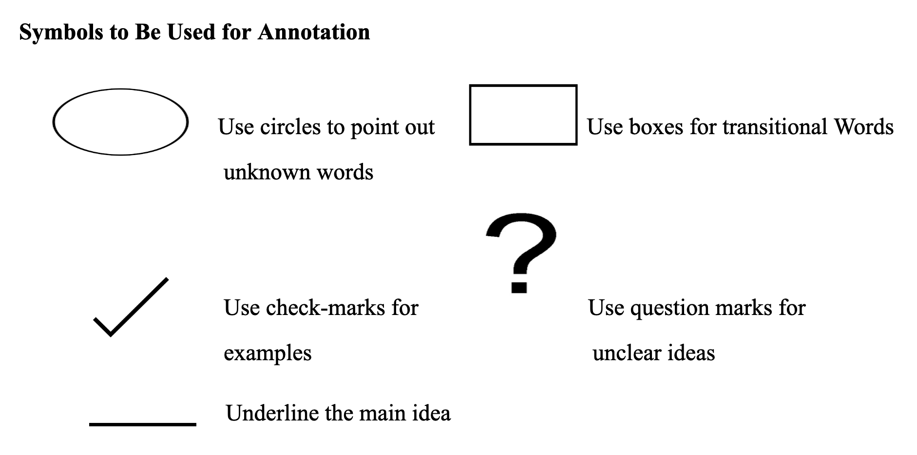

Besides these symbols, readers also write notes in the margin area to gather important information about the text. Therefore, there is a connection between the main ideas of the paragraphs and the notes someone writes in the margin area. Here, the reader must keep in mind that each paragraph of a text deals with only one main idea. Underlined main ideas are basically the marginal notes written in a group of words. In addition, these marginal notes must not be copied from the text. Rather, the notes in the margin are written using one’s own stock of vocabulary.

